5. Design

This section contain the design diagrams.
5.1 Technical Architecture Diagram

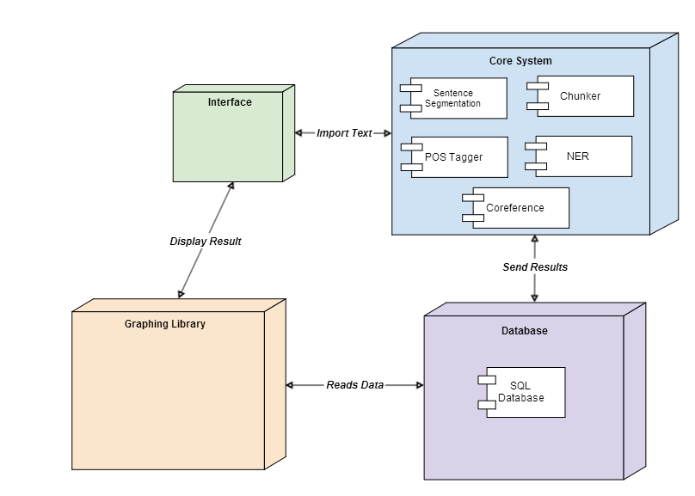

5.2 Entity Relationship Diagram
